Step #1: Oracle.com Login

To download both the Oracle XE database and the Oracle SQL Developer tool you will need an account on Oracle.com. Fortunately the account is free and open to anyone. All you need is a valid email address.

To sign up visit:

* <https://myprofile.oracle.com/EndUser/faces/profile/createUser.jspx>

Alternatively you can skip the above site and just follow the instructions for downloading Oracle XE or SQL Developer. When downloading either application the Oracle website will ask you for you Oracle.com username and password. If you don't already have one you can create one right there.

Step #2: Install Oracle XE

For this class you will need to have access to the Oracle database outside of the classroom. Oracle is not available in any of the labs at COD, and our classroom will not be available outside of normal class hours.

Fortunately you can download the Oracle database directly from Oracle to run on your Windows PC. I recommend that you download the version called "Oracle Database 11gR2 Express Edition" (also known as Oracle XE). This is a completely free version of the database with some [technical limitations](http://docs.oracle.com/cd/E17781_01/install.112/e18803/toc.htm#BABIECJA). It can only store 11gb of data, will only use 1 gb of memory, and will only use one CPU core. None of these restrictions will be a problem for this class. The software also installs very easily, especially when compared to the full version of the Oracle database.

Note that Oracle XE **will not** run on Windows Vista due to the security model that is part of that version of Windows. You must install it on either Windows XP or Windows 7.

To download Oracle XE you will need a free Oracle.com account. More details on that can be found [here](http://www.thatlink.com/Classes/cis2720sp14/Setup/TechnetLogin.aspx).

To download Oracle XE, visit the following page:

* <http://www.oracle.com/technetwork/database/database-technologies/express-edition/downloads/index.html>

Read and accept the terms, and then click the link to download the Windows 32bit version. Note that there is no 64bit version of Oracle XE, but the 32bit version appears to run correctly on 64bit machines (despite the warning on the page that it does not). The download is approximately 320mb, so it may take some time.

The software installs very easily. I highly recommend you reboot first, and then close any unnecessary applications.

**Make sure you write down the system password that you choose.** Without it you may have to reinstall Oracle XE at a later date.

Step #3: Install Oracle SQL Developer

In addition to the Oracle XE database you will also have to download the Oracle SQL Developer tool. SQL Developer is a graphical tool for database development. In general it is much easier to use than the command line tools Oracle has provided in the past (e.g. SQL*Plus).

You will be using SQL Developer both in in class and at home. Unfortunately SQL Developer is not installed on the computers in the classroom. We will discuss why this is in class. To use SQL Developer in class you will need to install it on your thumb drive, and remember to bring your thumb drive every week.

To download Oracle Developer, visit the following page:

* <http://www.oracle.com/technetwork/developer-tools/sql-developer/downloads/index.html>

You will need a [Oracle.com](http://www.thatlink.com/Classes/cis2720sp14/Setup/TechnetLogin.aspx) account to download the application. Be sure to download the "Oracle SQL Developer for 64-bit Windows" version (or use the 32-bit version at home if you have a 32-bit version of Windows) I recommend the version with the JDK bundled with it in case you don't have Java installed on your machine, but you can pick either the version with or without the JDK.

The file is in .ZIP format. Extract the contents to your thumb drive. The extracted contents take up about 220 megabytes of space. For example, you might use the "E:\sqldeveloper" folder.

That's it. Note that there is no installation program to run. To run SQL Developer navigate to the folder (e.g. "E:\sqldeveloper") in Windows Explorer. Then double click on the **sqldeveloper.exe** file.

# Step #4: Create Your User in Oracle XE

Make sure that you have already installed Oracle XE **and** Oracle SQL Developer before continuing. Perform this step on your home computer. You **do not** need to perform this step in the computer lab (it has already been done for you).

## Create a New Connection

Once you start SQL Developer, you will have to create a new connection. You can do this by clicking on the green plus sign icon located in the upper left portion of the window. See the screenshot below.

[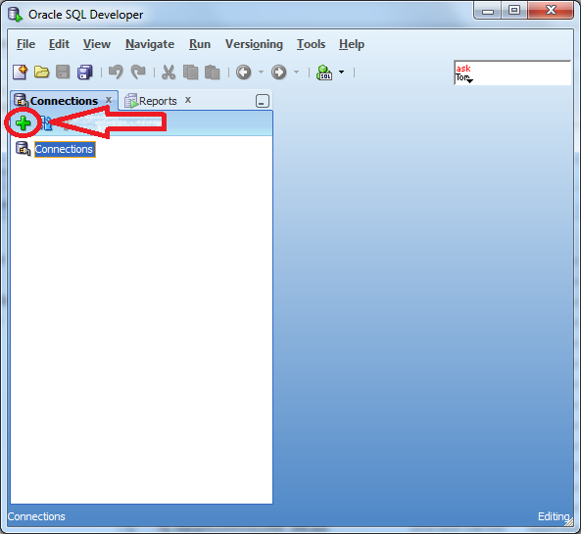](http://www.thatlink.com/Classes/cis2720sp14/images/OracleSQLDeveloperConnectionNew.png)

Enter the following information in the popup window:

* Connection name: xe-system
* Username: system
* Password: The password you selected when installing Oracle XE
* Click on Save Password (optional)

[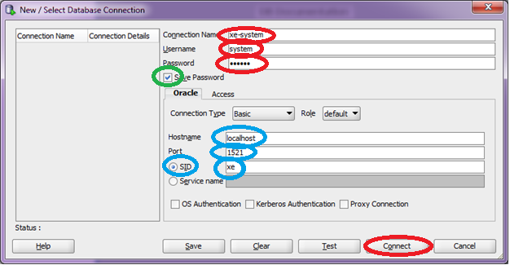](http://www.thatlink.com/Classes/cis2720sp14/images/CreateSystemConnection.png)

## Create Personal Account

Create a personal account for yourself. In this example I use the name kevin, but you can select anything that you want. All of you assignments should be done using this personal account. Only DBA tasks (like this one) should be done as the **system** or **sys** users.

Double click the xe-system connection in the tree control on the left. Then copy and paste the following SQL script into the text pane:

ACCEPT &&user PROMPT "Username:"

ACCEPT &&password PROMPT "Password:"

CREATE USER &&user IDENTIFIED BY &&password DEFAULT TABLESPACE users;

GRANT connect TO &&user;

GRANT resource TO &&user;

GRANT create view TO &&user;

ALTER PROFILE default LIMIT PASSWORD_LIFE_TIME UNLIMITED;

Then click the F5 button to execute. Enter a user name and password. Be sure to write down the password.

# Step #5: Creating a New Connection in SQL Developer

To create connect to an Oracle database using the Oracle SQL Developer tool you will have to create a new "connection". This page will show you how to do that. Note that you will need different parameters depending on whether you are using Oracle in the COD computer lab, or Oracle XE on your home computer. This page shows an example of each.

## Create a New Connection

Once you start SQL Developer, you will have to create a new connection. You can do this by clicking on the green plus sign icon located in the upper left portion of the window. See the screenshot below.

[](http://www.thatlink.com/Classes/cis2720sp14/images/OracleSQLDeveloperConnectionNew.png)

## In the COD Computer Lab

When connecting to the Oracle database from the computer lab at COD, you will have to change the following parameters to create the connection, circled in red on the screen shot below:

* Connection Name - This can be anything you want. It is the name on the connection. I like to use my username. In my case that's **stud24**.
* Username - This is the user name that I gave you the day of class. In my case it's **stud24**, but your's will be different. Note this is not your user name for Blackboard or MyAccess.
* Password - I gave this to you the first day of class. Note this is not your password to Blackboard or MyAccess.
* Hostname - use "cisoracle-1". This is the name of our Oracle database server. Note that "oracle" is completely spelled out (not abbreviated).
* SID - use "cis2720". This is the name of our Oracle database.

There are several other important parameters that default to the correct value. You should not have to change these values, but if you are having trouble connecting you should double check the values. These are circled in blue in the screen shot below:

* Port - use 1521. This is the default port number for Oracle databases.
* "SID" radio button - make use the "SID" radio button is selected, not the "service" radio button.

See the screenshot below for an example. Click the image to enlarge.

[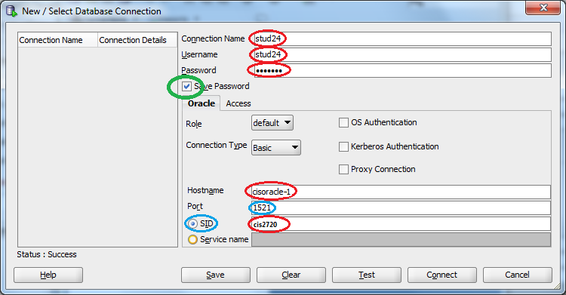](http://www.thatlink.com/Classes/cis2720sp14/images/OracleSQLDeveloperConnectionCOD.png)

## At Home Using Oracle XE

When connecting at home using Oracle XE you will need different parameters for you connection. You will have to change the following parameters to create the connection, circled in red on the screen shot below:

* Connection Name - This can be anything you want. It is the name on the connection. I like to use the database name followed by username. In my case that's **xe-kevin**.
* Username - This is the user name that you created after you install Oracle XE. It should not be **system** or **sys**. In my case it's **kevin**, but your's will be different.
* Password - This is the password that you used when you created your account.

There are two other important parameters that default to the correct value. You should not have to change these values, but if you are having trouble connecting you should double check the values. These are circled in blue in the screen shot below:

* Hostname - use "localhost". This is a special machine name that always refers to your own computer (where Oracle XE is installed).
* SID - use "xe". This is the name of our Oracle database. When using Oracle XE this is always set to "xe".
* Port - use 1521. This is the default port number for Oracle databases.
* "SID" radio button - make use the "SID" radio button is selected, not the "service" radio button.

You may also check the "save password" check box, if you like (circled in green below). This will save your password so that you do not have to type it in next time.

See the screenshot below for an example. Click the image to enlarge.

[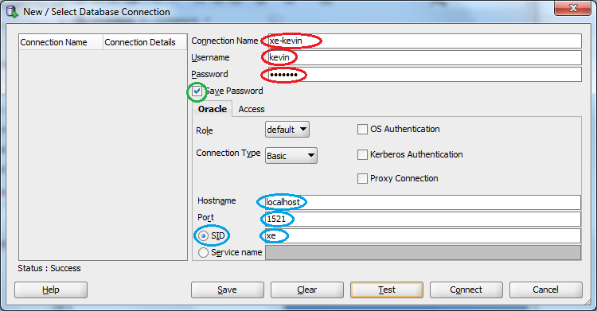](http://www.thatlink.com/Classes/cis2720sp14/images/OracleSQLDeveloperConnectionXE.png)

## Connection Summary

Here is a table summarizing the connection information for both the COD lab and Oracle XE at home. Replace **XX** with your student number. I've enlarged the font so you can tell the difference between the "1's" and "l's".

|  |  |  |
| --- | --- | --- |
|  | **COD Lab** | **XE @ Home** |
| Connection Name | studXX | Your choice |
| Username | studXX | The username you created |
| Hostname | cisoracle-1 | localhost |
| Port | 1521 | 1521 |
| SID | cis2720 | xe |

# Step #6: Build Database Tables Using SQL Developer

Before you start your homework and lab exercises, you will have to create the sample tables and other database objects that the author has built for us. These instructions show you how to do this using Oracle SQL Developer.

Before you can build your database you must have both the Oracle database (e.g. Oracle XE) and Oracle SQL Developer installed on your computer. You can find instructions for installing Oracle XE [here](http://www.thatlink.com/Classes/cis2720sp14/Setup/DownloadOracle.aspx).

If you have already built the author's tables and want to rebuild them you must drop them first. See the section at the bottom of this page that describes how to do this. Note that you do not need to do this if this is your first time running building the author's tables.

Note that you can click on any of the screenshots to make them larger.

## Part #1

Download the following to script to an empty directory on your computer. Please use these versions of the script rather than the version on the author's site. Both sets of files create the exact same tables, but I have made some changes to better work with our class.

Click on the link below for the SQLFUN_Build.sql script. Then click on the "Save to Desktop" link.

* [SQLFUN_Build.sql](http://www.thatlink.com/Classes/Main/DisplayFile.aspx?Section=cis2720sp14&OutType=HTML&Save=0&File=SQLFUN_Build.sql) [Save](http://www.thatlink.com/Classes/Main/SaveFile.aspx?Section=cis2720sp14&Save=1&File=SQLFUN_Build.sql)

[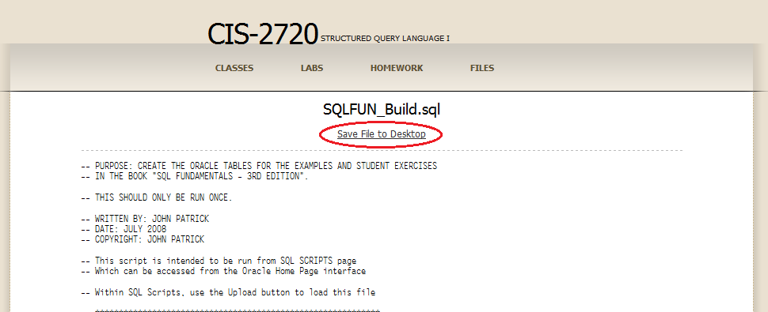](http://www.thatlink.com/Classes/cis2720sp14/images/BuildAuthorTables01.png)

## Part #2

Most browsers will ask you want to do with the file. Click on "Save". Later we will learn how to use the "Open" option as well, but for now use "Save".

[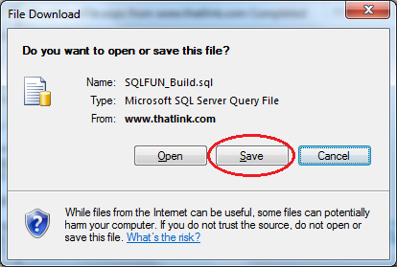](http://www.thatlink.com/Classes/cis2720sp14/images/BuildAuthorTables02.png)

## Part #3

Place the script in an empty folder. In this example I will use **C:\OraTMP**, but you can use any empty folder on your hard drive or thumb drive.

[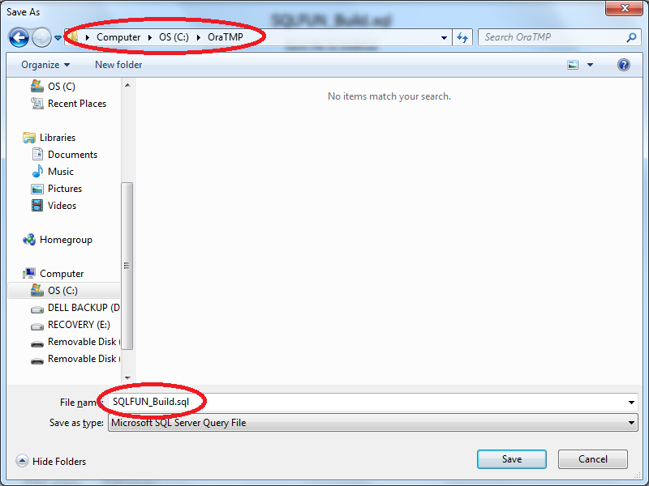](http://www.thatlink.com/Classes/cis2720sp14/images/BuildAuthorTables03.png)

## Part #4

Start up SQL Developer. Open your the script you downloaded by clicking the "file open" icon in the upper left, or clicking "File -> Open". Navigate to the directory you placed the script in, select the script, and then click "open".

[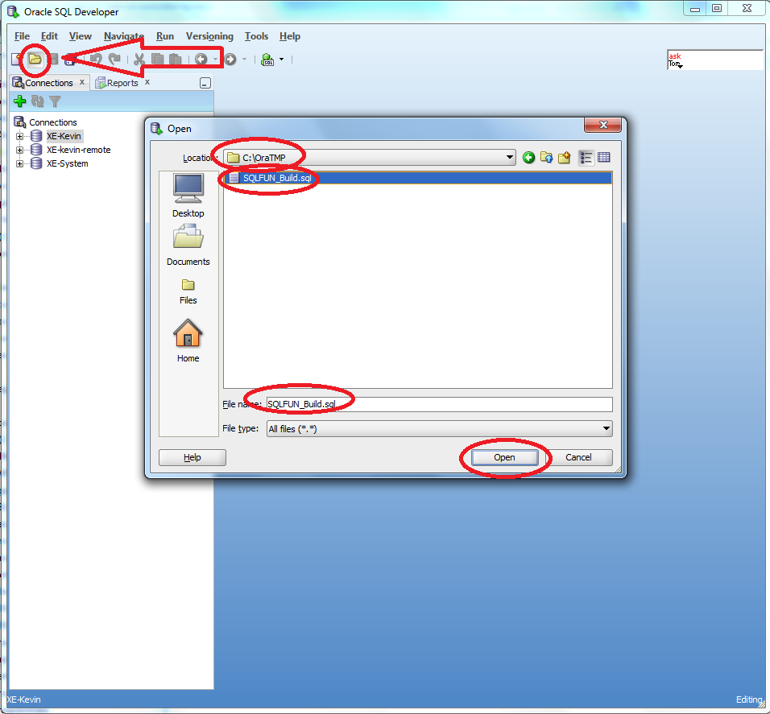](http://www.thatlink.com/Classes/cis2720sp14/images/BuildAuthorTables04.png)

## Part #5

Run the script by doing one of the following:

* Click on the green arrow icon with the document behind it. Do not click on the icon that is just a green arrow (they are located right next to each other).
* Press the "F5" key.

[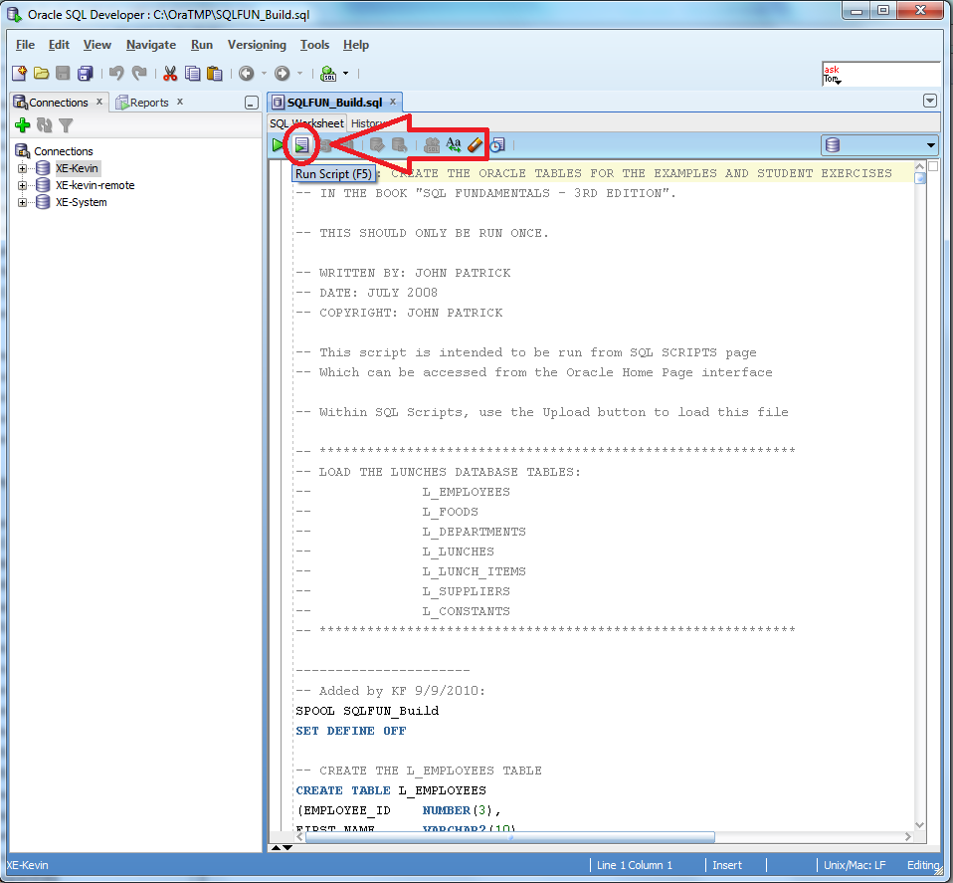](http://www.thatlink.com/Classes/cis2720sp14/images/BuildAuthorTables05.png)

## Part #6

SQL Developer will prompt you for the connection to use. You have already created this connection in a previous step. This connection should use the user account you plan to use (in my example it's "kevin"). Do **not** use a connection that connects as the **system** or **sys** user. Click "Ok".

[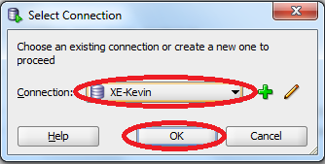](http://www.thatlink.com/Classes/cis2720sp14/images/BuildAuthorTables06.png)

## Part #7

It will take a minute or two for the script to run. The script will create over 200 tables. When you are done verify that the script ran correctly by checking the bottom of the "script output" panel. First check that you got four "OK"'s in the "status" column. Then check that there were not objects that were not built. It should say "0 rows selected" just above the word "Done". See the screenshot below for an example.

[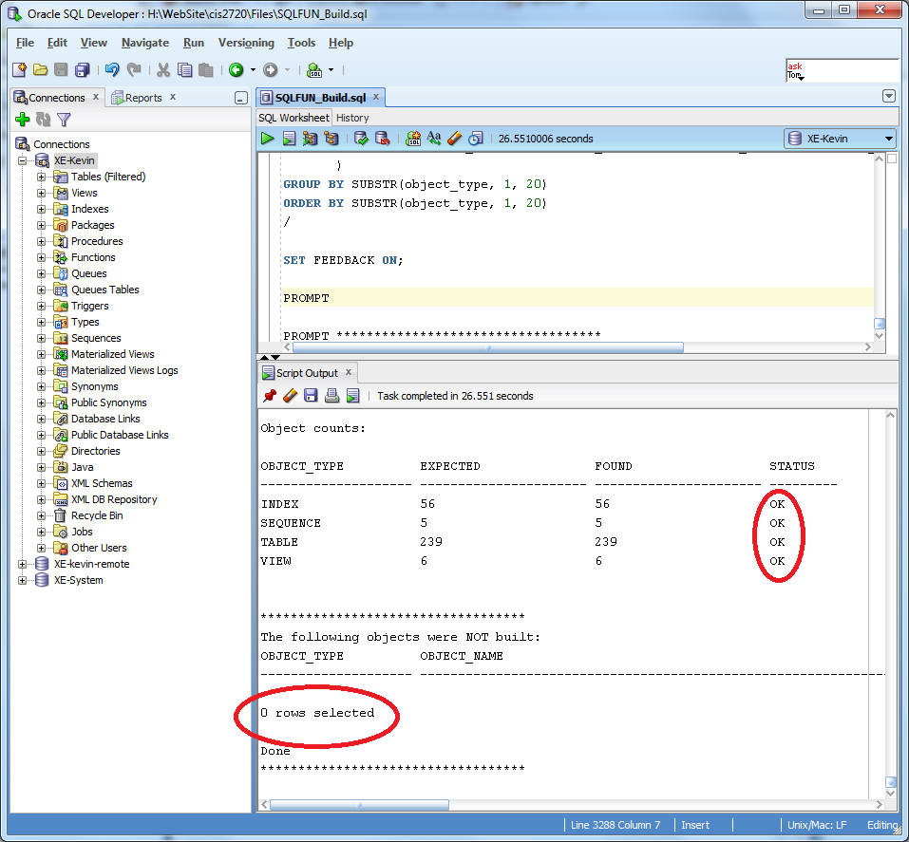](http://www.thatlink.com/Classes/cis2720sp14/images/BuildAuthorTables07.png)

## Re-Building the Author's Tables

At some point during the semester you will make a mistake and make a change to the author's tables that you didn't mean to. The easiest way to correct this is to drop all the authors tables and then rebuild them. To drop the authors tables simply run the following script:

* [SQLFUN_Drop.sql](http://www.thatlink.com/Classes/Main/DisplayFile.aspx?Section=cis2720sp14&OutType=HTML&Save=0&File=SQLFUN_Drop.sql) [Save](http://www.thatlink.com/Classes/Main/SaveFile.aspx?Section=cis2720sp14&Save=1&File=SQLFUN_Drop.sql)

This script can be run using the same process as the build script (described above). Once you have dropped all the authors objects you can rebuild them using the instructions above.